Parton Parish Council
c/o Jane Coltman
54 Gosforth Road
Seascale
Cumbria CA20 1PJ

17th July 2020 Quote Ref. 02295.QUO

Dear Jane

Subject: - Quotation for various repairs to Play Area

I have pleasure in submitting the following quotation: -

Item 1

Repairs to Gaitor mob ilus Total Price = £656.61 excluding vat

Item 2

Replace handle on mobilus Total Price = £297.40 excluding vat

Item 3

Change cradle seat Total Price = £182.42 excluding vat

Item 4

Rub down slide runner and paint Total Price = £92.36 excluding vat

This looks like it’s rusted through badly so may need fully replaced soon, I am sorting a price for a unit

If you would like us to carry out this work on your behalf, please confirm in writing to myself.

Yours sincerely
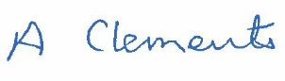

Alan Clements
Contracts Manager
01946 593037
OpenSpaces@copeland.gov.uk

